This document shall support you in order to configure a HD camera system during installation work. However, some items will depend on customers preference and need to discuss with the customer prior the setup.
Remark: Bold mark reflects the recommended setting for European customers.
1) SET THE MULTI-FORMAT
The Multi-Format is usually set from the MSU (Config Menu > CCU > Multi Format). It can be also set from MULTI FORMAT on page "S02" of the System Menu in the HDCU1000/1500 or with the switches on the AT-167 board.

1.1) Set the HD Output Format
The setting of the HD-SDI output is reflecting the shooting scan mode of the camera. • Set the Field Frequency Clock Coefficient Setup switch : S420 on the AT-167 board.

1.001 : Field frequency set into 1/1.001 time.
(Example: set the field frequency to 1.001 when using NTSC 525/59.94i signal in the SD system).
1.000 : Field frequency set into 1 time.
(Example: set the field frequency to 1.000 when using PAL 625/50i signal in the SD system.)
REMOTE : Set from the MSU connected or from MULTI FORMAT on Page "S02" of the System Menu in the HDCU1000/1500.

(Factory Setting: RMT)

Setup from MSU: Config Menu > CCU > Multi Format > System > 1.000 or 1.001 OR Setup from HDCU: System Menu > S02 MULTI FORMAT > Frequency HD: 1.000

• Set the Field Frequency

Setup switch: S418 on the AT-167.

60 V : When either the 60 field HD signal or the NTSC SD (525/60) signal is used.
(Factory setting: 60 V)
50 V : When either the 50i HD signal or the PAL SD (625/50) signal is used.
48 V : Only the 24PsF progressive system is supported.
• Set the Shooting Mode of the Camera.

Setup from MSU: Config Menu > CCU > Multi Format > 1080/50i OR
Setup from HDCU: System Menu > S03 MULTI FORMAT > CAMERA FORMAT 1080/50i

Setup switch (Local) : S419 on the AT-167 board (Factory setting : I )
I: When shooting in interlacing mode.
PsF: When shooting in progressive (PsF) mode.
720: When shooting with 720P.

1.2) Set the SD Output Format

Setup from HDCU: System Menu > S02 MULTI FORMAT > Frequency SD: 625

1.3) Assign the Video Signal Output

Set the Video Signal output from the MSU (Config Menu > CCU ) or in the CCU System Menu on Page S03.
The following settings are possible according to the camera format. The output Terminals from Slot 3 and upwards are optional Outputs.
Output terminalIn
1080/59.94iIn
1080/29.97PsFIn
1080/23.98PsFIn
720/59.94PIn
1080/50iIn
1080/25PsFIn
1080/24PsFIn
720/50P1-1&21080/59,94i1080/29,97PsF1080/23.98PsF720/59.94P1080/50i1080/25PsF1080/24PsF720/50P3&4M 1080/59.94iM1080/29.97 PsFM1080/23.98 PsFM 720/59.94PM1080/50iM1080/25 PsFM1080/24PsFM720/50P2-1&2525/59,94i525/29.97PsF1080/59.94i525/59.94i625/50i625/25PsF1080/50i525/50i3&4M 525/59,94iM525/29.97PsFM 1080/59.94iM 525/59.94iM625/25PsFM1080/50iM525/50iNTSCNTSC525/59.94iNTSCPALPAL625/50iPAL4--M525/59.94i---M625/50i-5--NTSC---PAL-
CAMERA Format
For the output format that starts with an "M", the signal with a character of HDCU is output.
1.4) Set the Character added to Video output

Factory setting S2-1 to ON (DRX-5 board) turns on the character MIX function of SDI monitor output (3, 4). If clean outputs are requested then S2-1 need to be set to ON.

2) SET THE REFERENCE INPUT

The reference input is usually set from MSU. It can also be set manually by the switch on the AT-167 board.
2.1) Set the reference input signal format
Setup switch : REFERENCE switch (S401) on the AT-167 board.
HD : When the HD SYNC is used.

REM : When the reference is set from MSU (Config Menu > CCU
Mode > Page 2 > Genlock Mode) or set from GENLOCK PHASE page "S01" of the System Menu in the HDCU.
SD : When the SD Black Burst Sync is used.

NOTE
When position is set into LOCAL, all of the REFERENCE settings including the phase adjustment must be set locally.

3) SET THE INTERCOM SYSTEM

3.1) Selecting the Intercom System
Select a system (4W, RTS or Clear-Com) respectively for the engineer line and the producer line according to the command system which is in use. Then, select the number of intercom line systems (1ch or 2ch). The most common system in Europe is 4W:

HDCU-1000/1500 : Set S602 and S603 (AVP-6 board) into 4W position (Factory setting)

3.2) Set the Headset Microphone

Select the microphone type:
HDCU-1500 : S5 on the AU-303 board (Carbon -20dB, Dynamic -60dB or ECM -40dB)
Adjust SIDE TONE on page "C05" of the configuration menu according customer's preference.

HDCU-1000 : S4 on the AU-302 board (Carbon -20dB, Dynamic -60dB or ECM -40dB)
Adjust SIDE TONE on page "C05" of the configuration menu according customer's preference.
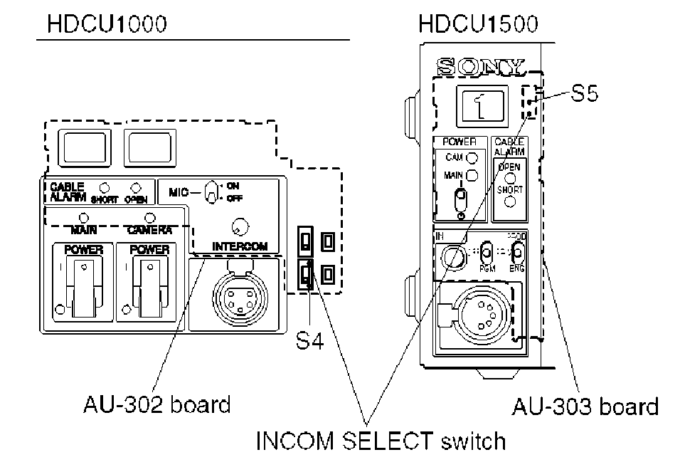

3.3) Set the Input Level of the PGM Audio
Set switches S502 (PGM1 IN) and S503 (PGM2 IN) on the AVP-6 board to 0 dBu or -20 dBu according to each level of audio 1 and 2 in the system.

Factory setting : 0 dBu

4) SET THE MICROPHONE LEVEL

To control the microphone input gain it is recommended to use the remote control via D-Sub or the manual setting on the board front panel. The HDC mic input gains can be set in a range of 60dB to 20dB in 10dB steps using either of the following methods.
When the MIC REMOTE connector on the rear panel is not connected or the levels of pin-8 (MIC 1) and pin-15 (MIC 2) of the MIC REMOTE connector has High level then the microphone input gain can be adjusted from CHU MIC GAIN on page "C04" in the configuration menu.

Factory setting : (60 dB)
4.1) Adjust the Microphone Input Gain by using the MIC REMOTE Connector
Set the microphone input gain control to ON or OFF with pin-8 and pin-15 of the MIC REMOTE connector on the rear as shown below. The input gain can be controlled via pin 5, pin 6 and pin 7 as shown below.

Pin No. Microphone connector

8 | 15 | MIC IN CH-1 | MIC IN CH-2
L | L | ON | ON
L | H | ON | OFF
H | L | OFF | ON
H | H | Internal setup | (Menu page "C04")

Setting the microphone input gain of the video camera

Pin No

Input gain |  | G | 5
60 dB | H | H | H
50 dB | L | H | H
40 dB | H | L (H) | H (L)
30 dB | L | L (H) | H [Li
20 dB | H | H (L) | L [Hi
H: +5 V or OPEN
L: GND
Input resistance : Pulled-up 100 kOM +5 V
The setup for the HDCU-700A mode is shown in parenthesis ( )
S406-2/AT-167 -> ON

4.2) Adjust the MIC Signal Phase

When the PGM microphone signal phase is in advance relating to the video signal phase, then adjust the audio phase from HDCU-1500/1000 Configuration Menu > Page C04 MIC AUDIO > MIC OUT DELAY.
When the microphone signal phase is advanced to the video signal phase, adjust the audio delay from MIC OUT DELAY on page "C04".

Factory setting : 0 Fs
4.3) Adjusting the MIC output level
Select the microphone output signal level (0 dB, -20 dBu) from the MIC 1, 2 connector on the rear panel by using the switches on the AVP-6 board.
• Setting the output level of MIC 1 :
Switch S500 (MIC 1 OUT LEVEL)

• Setting the output level of MIC 2 :
Switch S501 (MIC 2 OUT LEVEL)

• Factory setting : 0 dBu (both S500 and S501)
The microphone output signal level from the MIC 1, 2 connector on the rear panel can be adjusted by using the volume on the AVP-6 board.

• Setting the output level of MIC 1 :
RV500 (MIC 1 OUT LEVEL)

• Setting the output level of MIC 2 :
RV501 (MIC 2 OUT LEVEL)

5) SETTING THE VIDEO SYSTEM

5.1) Signal Phase Adjustment
Select the type of external sync signal according 2) Setting the Reference Input HD : HD SYNC
REM : Control is performed by MSU
Factory setting: REM SD : SD Black Burst Signal

For HD sync : For coarse adjustment of the H phase use H-STEP on page "S01" of the CCU
System Menu. For fine adjustment use the H PHASE switch on the AT-167 board panel.

For SD sync : For coarse adjustment of the H phase use H-STEP on page "S01" of the CCU System Menu. For fine adjustment use the H PHASE switch on the AT-167 board panel.
If an optional ENCODER board is used, the SC PHASE adjustment on the EN-159A/159B board panel is also necessary (HKCU1001/1003 fitted and if BB signal have been selected for genlock signal).
5.2) Setting the Aspect Ratio during Down Conversion
The desired aspect ratio can be set if
- using the MIC REMOTE connector at the rear panel of the HDCU1000/1500
- or SD ASPECT on page "S04" of the CCU System Menu in the HDCU1000/1500.
- or from MSU-900/950 Maintenance or Configuration Menu.


Examples of display
Letter box (16 : 9)
The 16:9 ratio picture is inserted into the 4: 3 ratio picture without changing the ratio and is output in the SD SDI format.
Semi-letter box (15 : 9) The picture that is cut out with the aspect ratio of 15 : 9. is inserted into the 4 : 3 rati picture and is output in the SD SDI formal

16 : 9 picture (picture from camera)
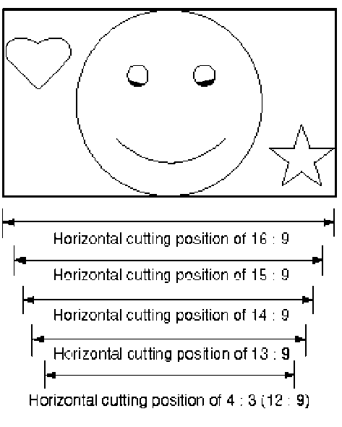

Picture whose aspect ratio is converted (SD SDI output)




Semi-letter box (13 : 9) The picture that is cut out with the aspect ratio of 13 : 9. is inserted into the 4 : 3 ratio picture and is output in the SD SDI format.
Edge-crop
CROP POSITION can be changed
Semi-letter box (14 : 9) The picture that is cut out with the aspect ratio of 14 : 9. is inserted into the 4 : 3 ratio picture and is output in the SD SDI format.
Squeeze
The 16:9 ratio picture is output in the SD SDI format without changing the ratio.


5.3) Adjust the Delay of Down Conversion according the desired System Setting.

HDCU-1000/1500 : AT-167 board - S410 (HD-SD DLY)
Selects the delay between the HD SDI output signal and the SD SDI signal after down conversion process.

0-DLY : Same phase between HD and SD output
LINE-DLY : Sets the minimum delay between HD and SD, 90H (1080i) or 120H (720P).
FRAME-DLY : SD signal delay, 1 frame (1080i) or 2 frames (720P). Factory Setting: LINE-DLY
Examples:
- If using HD outputs on HDCU-1500/1000 mixed with HDCU-900/950, set LINE-DLY.
- If using HD and SD outputs on HDCU-1500/1000 mixed with HDCU-900/950, set FRAME-
DLY.
- If using HD outputs on HDCU-1500/1000 only, set LINE-DLY.
- If using HD and SD outputs on HDCU-1500/1000 only, set 0-DLY.

Note: If camera format setting is 24PsF and the 0-DLY mode have been set, then the setting is
treated as FRAME-DLY.
5.4) Setting the RET Input Signal Format
HDCU-1500/1000 : RETURN FORMAT on page "S05" of the System Menu of HDCU-1500/1000 or from Maintenance Menu in MSU-900/950.

Note for HDCU-1500 : Although the HDCU1500 only has 3 RET inputs, the Prompter signal input on the rear panel can be used as the RET4 signal. (The RET4 input format is VBS only.)

Terms:
Letter box : The HD video signal of 16 : 9 or other aspect ratio is inserted into the picture frame of 4 : 3 and converts into SD signal (4 : 3). The black level is inserted into top and bottom of the picture.
Edge-crop : Video signal 4 : 3 aspect ratio is cut from HD 16 : 9 video signal and is converted into a SD signal (4 : 3).
Squeeze : The HD video signal with 16 : 9 aspect ratio is directly converted into SD signal as 16 : 9 ratio.



Examples of display
Edge-crop
Picture on the HDC-1500/1000 viewfinder
Squeeze
Letter box (16 : 9)
RETURN VIDEO input picture
The rightmost end and the leftmost end are cut and replaced by black on the vlewflnder.
The same picture as the camera output picture is shown.
The same picture as the camera output picture is shown.



5.5) Setting the CCU Colour Bar
Semi-letter box (15:9)
Semi-letter box (14:9)
Semi-letter box (13:9)
When the signal was up-converted in the edge-crop mode
When the signal was up-converted in the edge-crop mode
When the signal was up-converted in the edge-crop mode

HDCU-1500/1000 : Configuration Menu > C00 page COLOR BAR
HD-BAR SEL : BAR 16:9 (75%)
SD-BAR : EIA

5.6) Adjust the WFM Output Levels

HDCU-1500/1000 : Installation Manual page 2-21.

5.7) Adjust the PIX Output Levels

HDCU-1500/1000 : Installation Manual page 2-24.
6) CAMERA REFERENCE FILE SETTING (Optional)
- Set 1080 / 50i and perform AUTO LEVEL SETUP.
- Set DTL and Matrix to ON (HD and SD).
- On MSU-700, ensure MSU CONFIG > CAMERA > WHITE SET-UP MODE is set to AUTO LEVEL, unless customer preference is for AWB
Note: default is AWB and may be preferred for OB applications, however AUTO LEVEL is usually prefered for studio installations.
- Set Test 2 to ON via MSU (Knee OFF) and confirm level at SDI outputs are ok.
- Ensure in Camera Config Menu that OHB Matrix Correct is set to OFF (unless there is a specific requirement for it to be ON), and ensure that Auto White Shading Mode is set to RGB.
- Select CLOSE. Via MSU perform Auto Black Shading, FILE > OHB FILE >AUTO B.SHADING.
Store OHB File.
- Adjust Master Pedestal for 20mV.
- Set TEST 2 ON and adjust White for 700mV.
- Set TEST 2 ON and adjust HD and SD Gamma = 420mV for Gamma 0.45 via MSU PAINT menu.
- Set TEST 1 (KNEE ON), +9dB, ensure Knee Point set to 95% (665mV) or customers preference, set Knee Slope to 750mV or customers preference (Clip OFF).
- Set White clip to 105% (735mV) or customers preference.
- Set 0dB Gain and TEST 1 to OFF.
- Adjust HD and SD Detail parameters to customers preference as required via MSU PAINT menu.
- Set the HD and SD MATRIX (SD ON or OFF) to customers preference.
- Store the Reference File. Select FILE > REFERENCE > REF STORE > START.
- Run Auto Level Setup. Ensure all parameters are good on Test signals, if not re-adjust Ref File & run Auto Level again.
- Check Flare performance on Greyscale chart with a reference lens. If necessary, make adjustments on Flare and store the data from MSU into a Reference File.
- Check for the appropriate lens name on MSU or from Camera Menu. If not found then select OFFSET with the correct F-stop number from camera lens file menu and store it in a lens file.
- Shoot a lightbox white area and zoom in (approx 90%) ensuring correct framing and de-focus lens. Ensure auto iris is set to ON. Perform Auto White Shading, FILE > OHB FILE > AUTO W.SHADING Perform OHB STORE. Repeat it for 2x extender position.
Note, that the Reference File of HDCU is stored into the camera. The HDCU data are backed up in the camera (AT-board). If a camera is connected to a different HDCU, the reference file which the camera had backed up will be sent to the HDCU, and will overwrite the previous reference file data of the HDCU. So the reference file data of HDCU and the camera are always the same.

SD Data which are transmitted onto the AT-board of HDCU.
- CHROMA ON/OFF
- SD MATRIX ON/OFF
- SD DETAIL ON/OFF
- SD DETAIL LEVEL
- SD DETAIL LIMITER
- SD DETAIL LIMITER WHITE
- SD DETAIL LIMITER BLACK
- SD DETAIL CRISPENING
- SD DETAIL LEVEL DEPEND
- SD DETAIL FREQUENCY
- CROSS COLOR REDUCE ON/OFF
- CROSS COLOR REDUCE LEVEL
- CROSS COLOR REDUCE CORING
- ASPECT SELECT
- EDGE CROP POSITION
- SD GAMMA ON/OFF
- SD MASTER GAMMA
- H INTERPOLATION COEFF SELECT
- V INTERPOLATION COEFF SELECT

END
CCU Menu
